BÀI TẬP TUẦN 5

*Nguyễn Thị Ngọc Mai – 22025510*

*Bài tập 7.23 và 7.25 - giáo trình Fundamentals of DB system*

7.23  
Consider the ER diagram shown in Figure 7.21 for part of a BANK database.  
Each bank can have multiple branches, and each branch can have multiple  
accounts and loans.  
*a. List the strong (nonweak) entity types in the ER diagram.*  
- Strong entity types: BANK, ACCOUNT, LOAN, CUSTOMER  
  
*b. Is there a weak entity type? If so, give its name, partial key, and identifying  
relationship.*- Weak entity type: BANK_BRANCH  
- Partial key: Branch_no  
- Identifying relationship: BRANCHES   
  
*c. What constraints do the partial key and the identifying relationship of the  
weak entity type specify in this diagram?*- 1 BANK_BRANCH sẽ có 1 Branch_no, liên kết BRANCHES biểu diễn rằng mỗi BANK_BRANCH khác nhau sẽ có 1 Branch_no khác nhau, mà tất cả các BANK_BRANCH này đều từ cùng 1 BANK. Branch_no kết hợp với Khóa chính Code ở BANK sẽ tạo nên 1 bộ khóa hoàn chỉnh cho 1 BRANCH_BANK.

*d. List the names of all relationship types, and specify the (min, max) constraint on each participation of an entity type in a relationship type.  
Justify your choices.*  
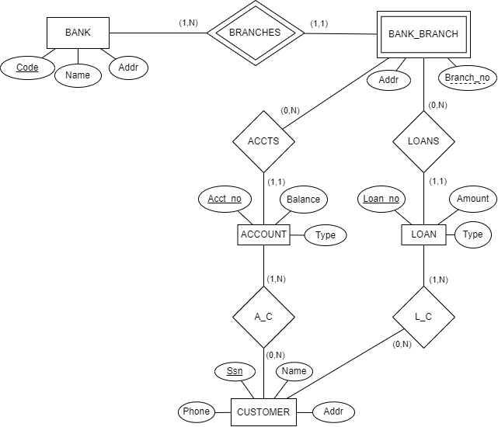

- BRANCHES:

+ (1,N): BANK has a total participation

+ (1,1): BANK_BRANCH has a total participation  
- ACCTS:

+ (0,N): BANK_BRANCH has a partial participation

+ (1,1): ACCOUNT has a total participation  
- LOANS:

+ (0,N): BANK_BRANCH has a partial participation

+ (1,1): LOAN has a total participation  
- A_C:

+ (1,N): ACCOUNT has a total participation

+ (0,N): CUSTOMER has a partial participation  
- L_C:

+ (1,N): LOAN has a total participation

+ (0,N): CUSTOMER has a partial participation

*e. List concisely the user requirements that led to this ER schema design.*

* The database holds information of banks, which includes the code, name, and address. One bank may have one or multiple branches, if the bank has one branch, the bank is the branch itself. The bank branch will have a branch number, and an address.
* Each bank keeps track of each customer’s name, social security number, phone number and address.
* A customer can open many bank accounts at a time, a bank account can be shared by many customers. Each bank account has an account number, an account type, account balance and only belongs to one branch.
* The bank branches allow customers to take out loans. One loan is linked to one branch only but can be shared among customers. The database stores each loan’s loan number, type, and amount.

*f. Suppose that every customer must have at least one account but is  
restricted to at most two loans at a time, and that a bank branch cannot have more than 1,000 loans. How does this show up on the (min, max) constraints?* 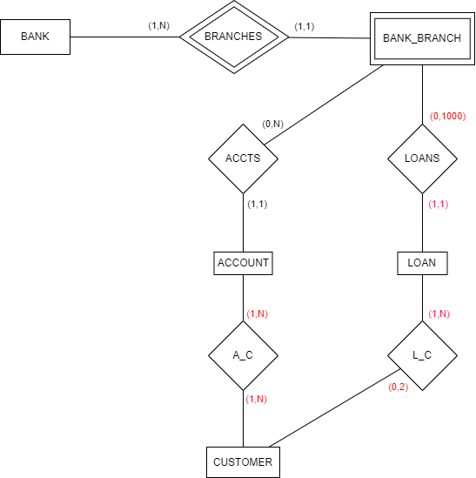

7.25  
*Consider the ER diagram in Figure 7.23. Assume that a course may or may not use a textbook, but that a text by definition is a book that is used in some course. A course may not use more than five books. Instructors teach from two to four courses.   
Supply (min, max) constraints on this diagram. State clearly any additional assumptions you make.*

- Assumption: A course can be taught by up to 3 instructors.   
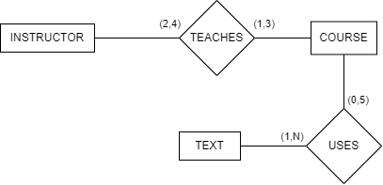

*If we add the relationship ADOPTS, to indicate the textbook(s) that an instructor uses for a course, should it be a binary relationship between INSTRUCTOR and TEXT, or a ternary relationship between all three entity types? What (min, max) constraints would you put on it? Why?*   
- Binary relationship between INSTRUCTOR and TEXT (ADOPTS) is sufficient enough to accurately describe the semantics of all three entity types. It can store all the necessary information as a binary relationship.  
- Constraints on ADOPTS:

+ (0,20) with INSTRUCTOR: Because an instructor can teach up to 4 courses, each course can use up to 5 textbooks so the maximum will be 4x5=20 (textbooks). The minimum will be 0 because a course may not use a single textbook.

+ (1,N) with TEXT: A single textbook can be adopted by many instructors, so the maximum will be N. Moreover, textbook must be adopted by at least one instructor that teaches one course using that textbook, so the minimum will be 1.   
